2021 Sample Social Media Posts
Here are a few templates with pictures! You can customize and share these on your platforms to get your community and network involved to support your team!
Don’t forget to tag us!
Instagram: secondharvestfoodbankoc
Facebook: secondharvestfoodbankoc
Twitter: secondharvestFB
LinkedIn: Second Harvest Food Bank of Orange County
YouTube: SecondHarvestOC

Teaser / Campaign is coming
We are so excited to participate in Second Harvest Food Bank’s Food From The Bar campaign this year. The campaign runs June 1 – July 2 and is a friendly competition amongst OC’s legal community to “do the most good!” FFTB supports Second Harvest’s mission to end hunger in Orange County and we are thrilled to play a part in helping our community. We kick off on June 1st and hope to have your support in helping provide meals to those in need. Check back soon to see how you can help us win this give-back campaign!

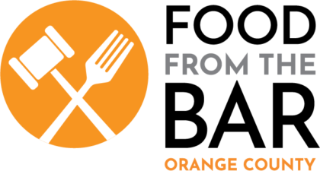

Campaign Launch
(COMPANY NAME) friends! We kick off the Food From The Bar campaign today! We are excited to participate in this friendly competition amongst OC’s legal community that helps feed those in need in Orange County. We have a goal to raise $XXX to provide (goal x3) meals! To support our team, you can make a contribution to Second Harvest by virtually ‘shopping’ on this fun and interactive website to help provide food to people in need OR share this post to help spread the word! Be sure to direct your donation to (COMPANY NAME)’s team!
Click here to donate to support our team: https://www.yourfooddrive.org/#FFTB2021

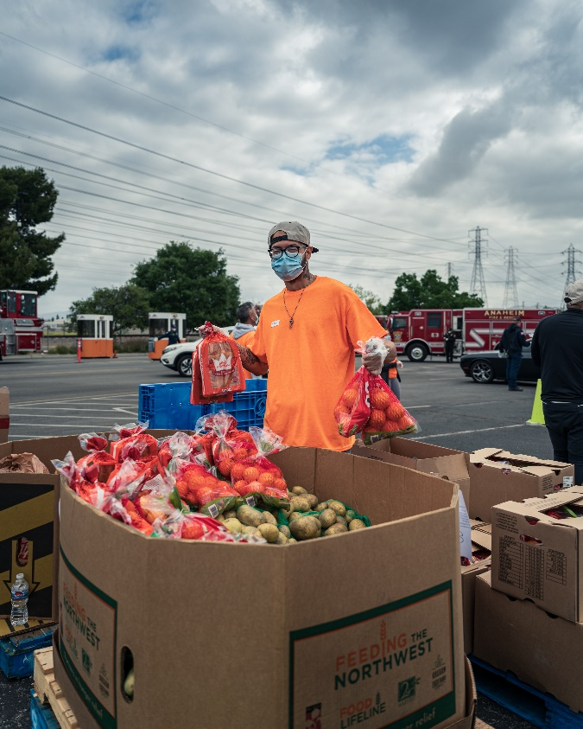

Progress Post/Mid-campaign
We are halfway through the Food From The Bar campaign! It has been so fun to see our community come together for the greater good and put food on the table for those experiencing food insecurity in Orange County. Our goal is to raise $XXX, to date we have raised $XXX to help feed those in need. Talk about impact! With a few weeks left to go, we can make a deeper impact with your help! Visit the link below to support our team. Every dollar helps provide 3 meals!
https://www.yourfooddrive.org/#FFTB2021

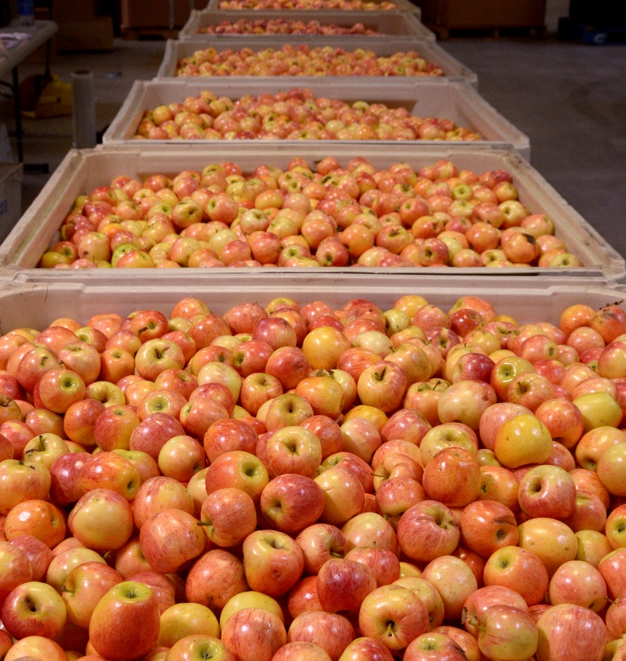

Last Day of the Campaign
We’ve made it to the end of the Food From The Bar campaign! Today is our LAST DAY to reach our goal of $(COMPANY GOAL) and help provide (goal x3) meals to those in need. A big thank you to everyone who has supported us throughout the month, whether you have given monetarily, shared our posts, or talked about it with your friends, we appreciate you! If you would like to make an ‘at the finish line’ donation before the end of today, you may do so here: https://www.yourfooddrive.org/#FFTB2021

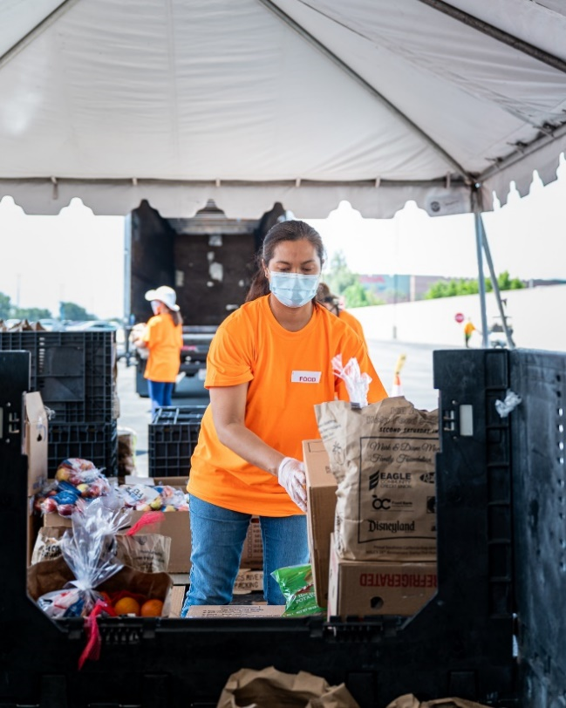

Post Campaign
Thank you to everyone who supported @ (your company handle) in this year’s Food From The Bar campaign! Our team raised (amount you raised) for Second Harvest, and the overall campaign raised $(amount raised overall). That means we helped provide XXX meals to help feed those in need across Orange County. Thank you, we could not have done it without you!

